

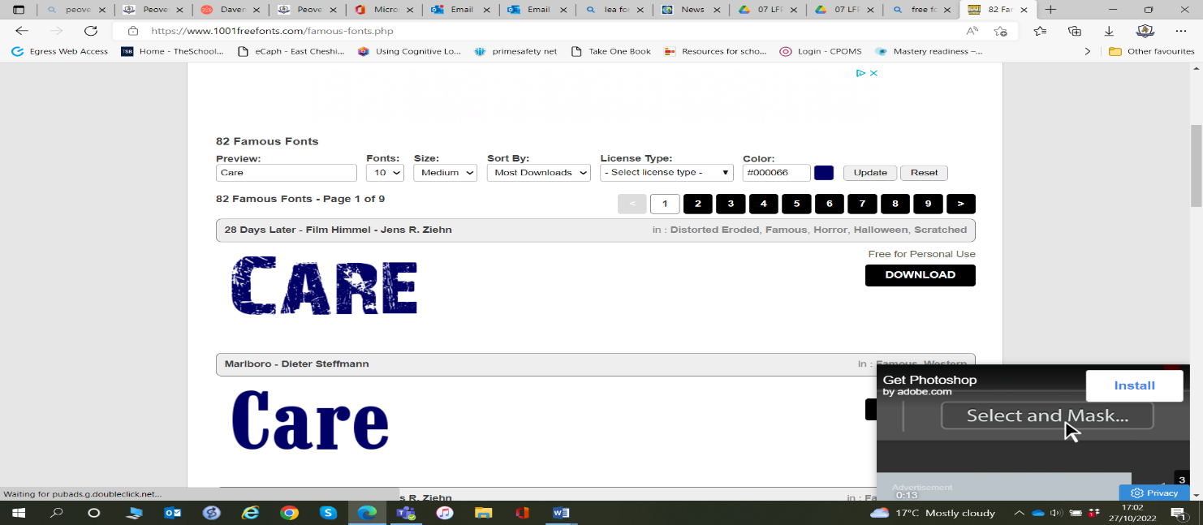
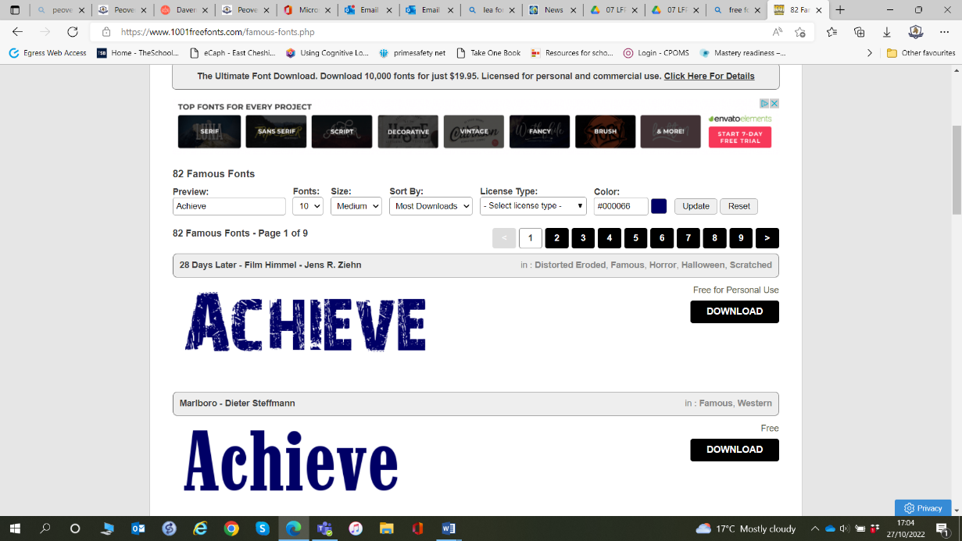
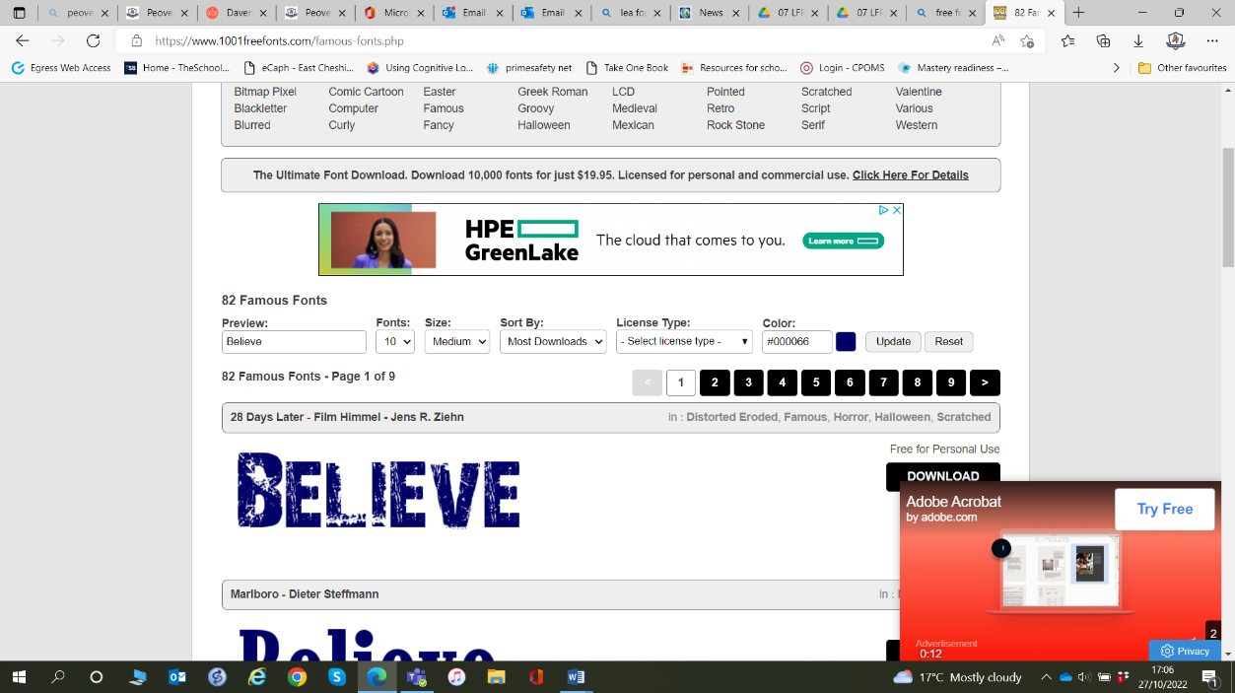

2026_2027

Summer 1 – Creativity, Challenge and Team Spirit
Big Idea: We achieve great things when we use our talents, challenge ourselves and work together.

School Values: Achieve, Believe
British Value: Be Yourself, Show Respect, Everyone has a voice
Week 1 | Everyone Has Something Special  - Big Question: What makes you uniquely you?
Week 2 | Every Voice Matters  - Big Question: Why is it important that everyone is heard?  Text: The day the crayons quit
Week 3 | Finding Our Creativity  - Big Question: How can we express who we are?
Week 4 | The Power of Teamwork  Big Question: What can we achieve when we work together?
Week 5 | The Lion Inside Revisited  - Big Question: How have we grown this year?  Text: The Lion Inside
Week 6 | Personal Best  - Big Question: How can I challenge myself?
Week 7 | Sportsmanship and Team Spirit  - Big Question: Why is respect important in competition?

