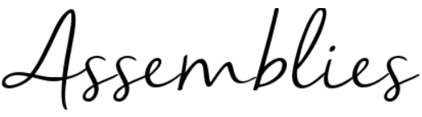

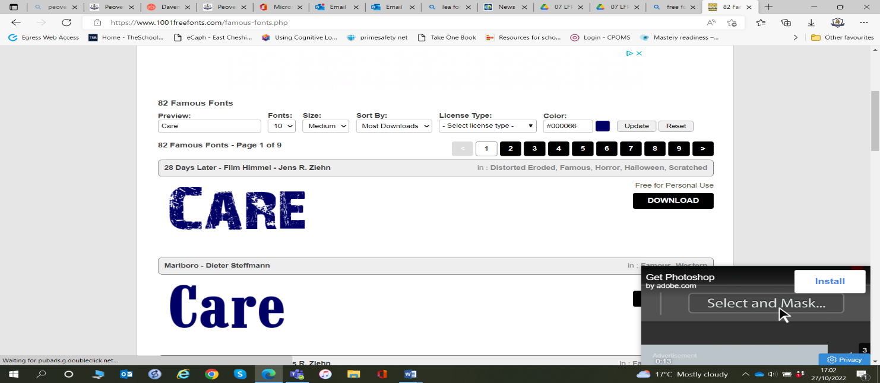
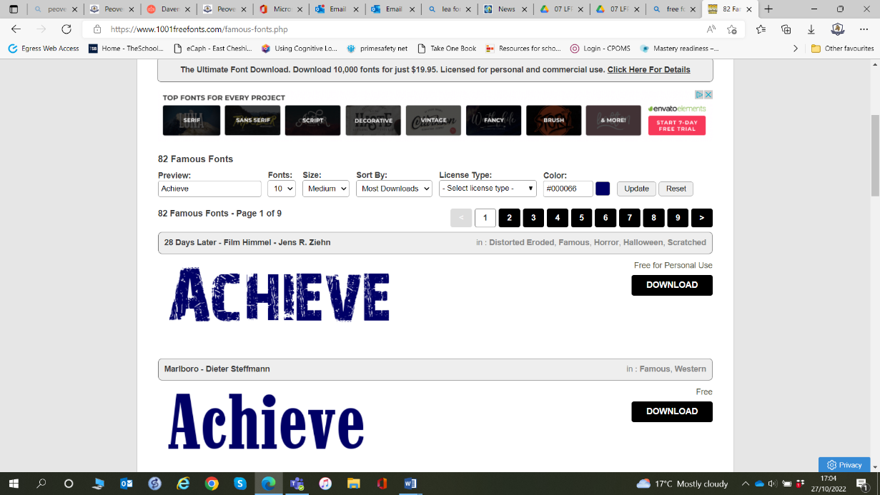
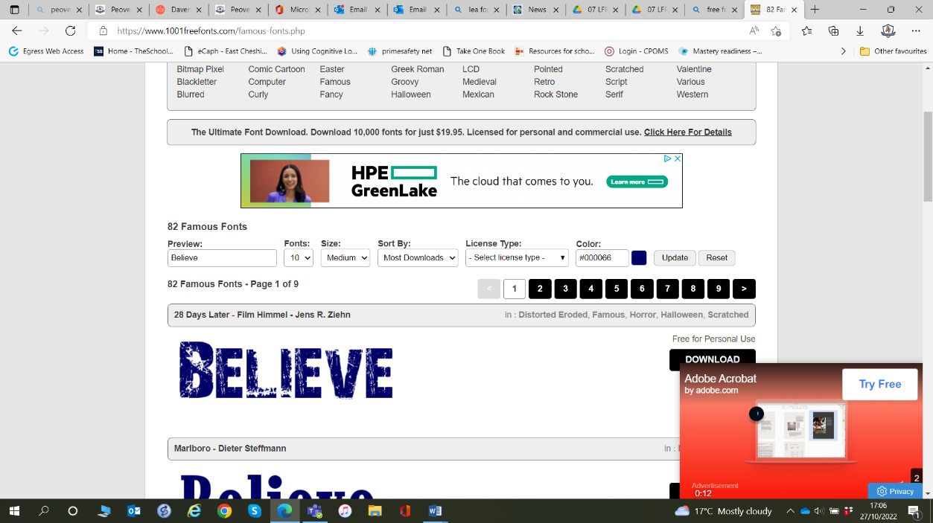

2026_2027

Summer 1 – Responsibility, Community & Making a Difference
Big Idea: We all have a responsibility to care for our world and contribute to our community

School Values: Care
British Value: Stay safe & fair, Everyone is welcome, Everyone has a voice
Week 1 | Responsibility Starts With Me  - Big Question: How do my choices affect other people?  Text: What If Everybody Did That?
Week 2 | Small Actions, Big Impact  - Big Question: Can one person really make a difference?
Week 3 | Caring for Our Planet  - Big Question: Why should we look after the world around us?
Week 4 | People Who Help Our Community  - Big Question: Who helps make our community a great place to live?
Week 5 | Everybody Has a Part to Play  - Big Question: How can I contribute to my community?
Week 6 | Proud to Be Part of Peover  - Big Question: What difference have we made this term?

