
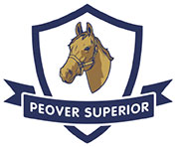
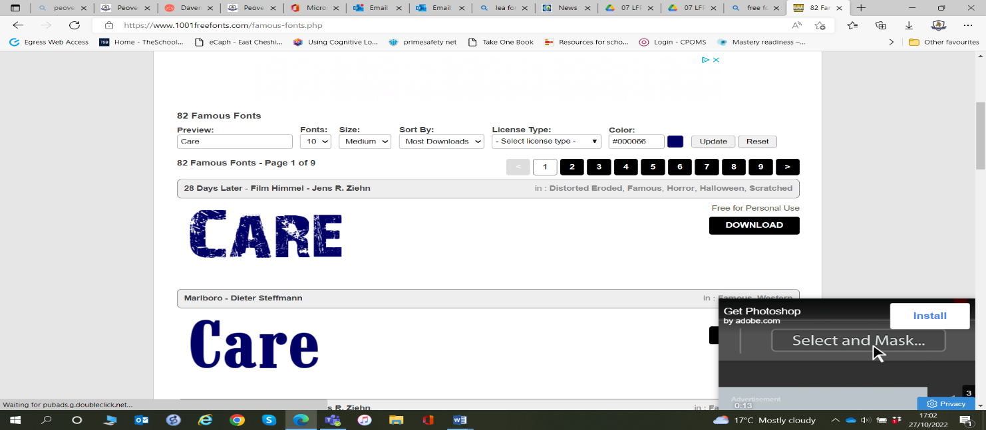
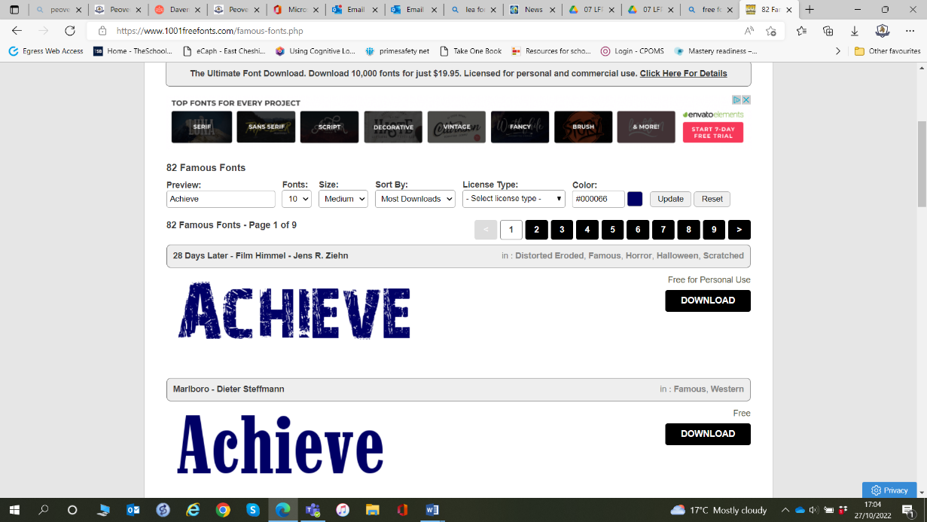
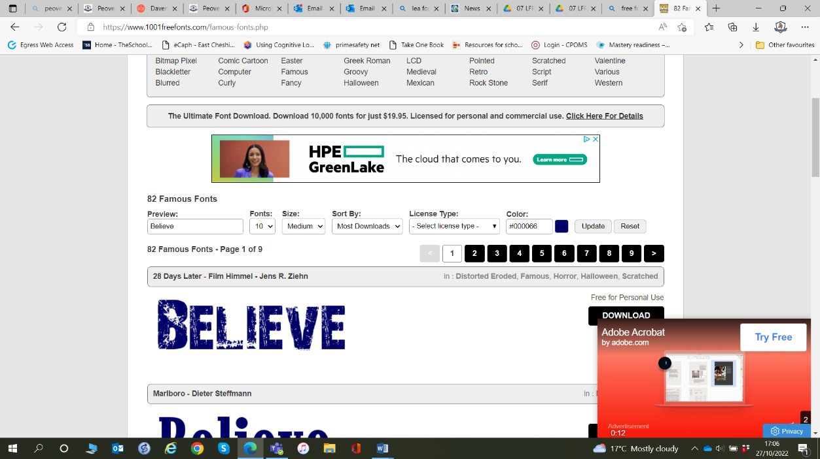

2026_2027

Spring 2 – Curiosity, Questioning & Discovery
Big Idea: Great learners ask great questions.

School Values: Achieve
British Value: Be Yourself, Everyone has a voice
Week 1 | Why Ask Questions?  - Big Question: How do questions help us learn?
Week 2 | Here We Are  - Big Question: What kind of world do we want to create together?  Text: Here We Are
Week 3 | Being Curious  - Big Question: What happens when we wonder about the world?
Week 4 | Learning Through Discovery  - Big Question: Why is it okay not to know the answer?
Week 5 | What Will You Discover?  - Big Question: What could you achieve if you stayed curious?

