

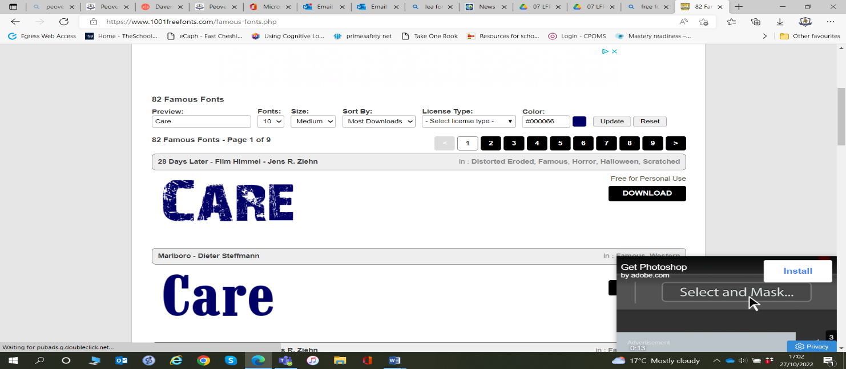
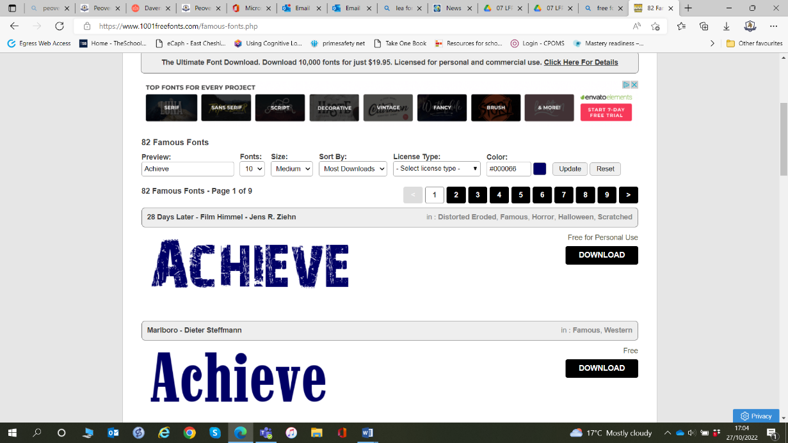
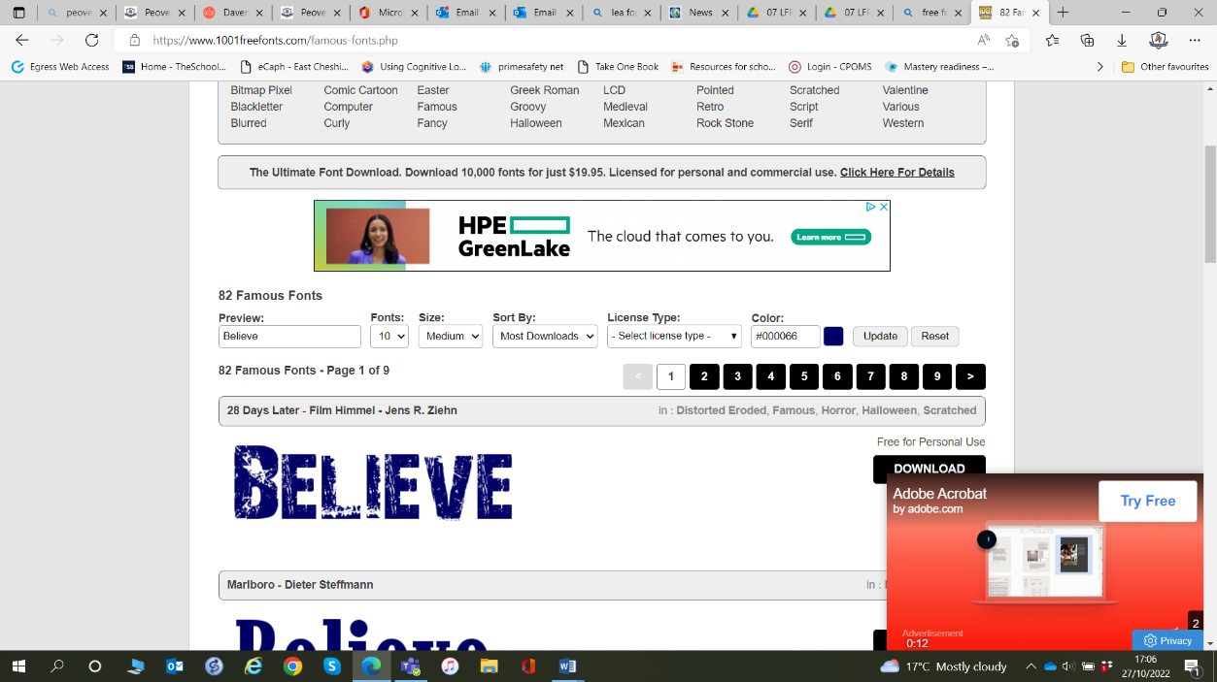

2026_2027

Spring 1 – Growth, Goals and Challenge
Big Idea: We grow when we challenge ourselves.

School Values: Achieve, Believe
British Value: Be Yourself
Week 1 | Dream Big  - Big Question: What would I achieve if I believed I could?
Week 2 | Make Your Mark  - Big Question: What happens when we are brave enough to have a go?  Text: The Dot
Week 3 | The Power of Yet  - Big Question: What can I not do... yet?
Week 4 | Learning From Mistakes  - Big Question: Why are mistakes important?
Week 5 | Never Give Up  - Big Question: What helps us keep going when things get difficult?
Week 6 | Celebrating Growth  - Big Question: How have I grown this half term?

