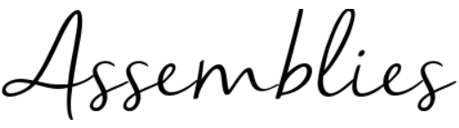

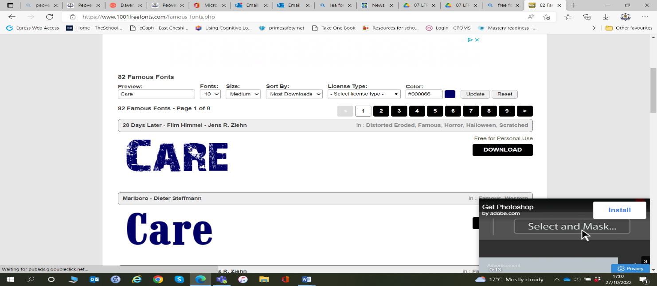
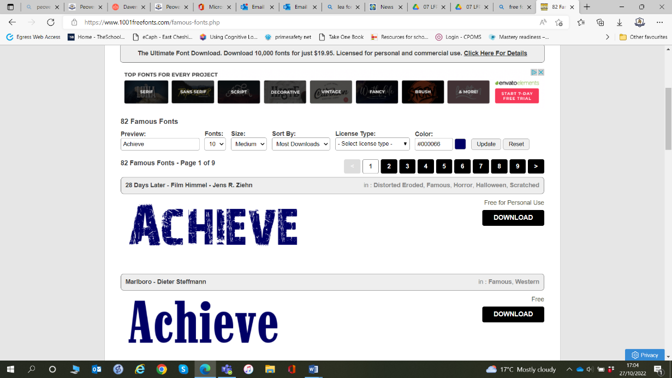
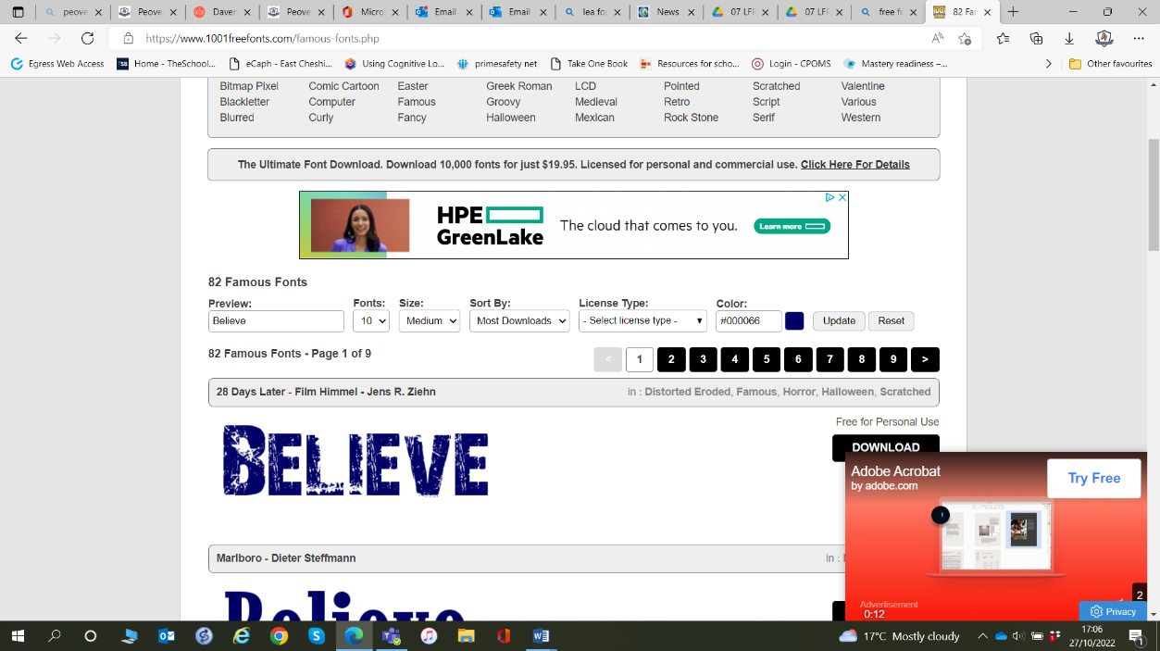

2026_2027

Autumn 2 – Kindness, Respect and Community
Big Idea: The way we treat others helps our community grow.

School Value: Care
British Values: Show Respect. Everyone is Welcome
Week 1 | Kindness Matters  - Big Question: How can one act of kindness change someone's day?
Week 2 | Bucket Fillers and Bucket Dippers  Text: Have You Filled Your Bucket Today?  - Big Question: How do our words and actions affect other people?
Week 3 | Respect Starts With Me  - Big Question: What does respect look like in our school?
Week 4 | Choosing Kindness  - Big Question: Can kindness be a choice?
Week 5 | Helping Our Community  - Big Question: How can we make Peover even better?
Week 6 | Everyone Plays a Part  Big Question: Why is every member of our community important?
Week 7 | Joy and Celebration  - Big Question: Why do communities celebrate together?

