

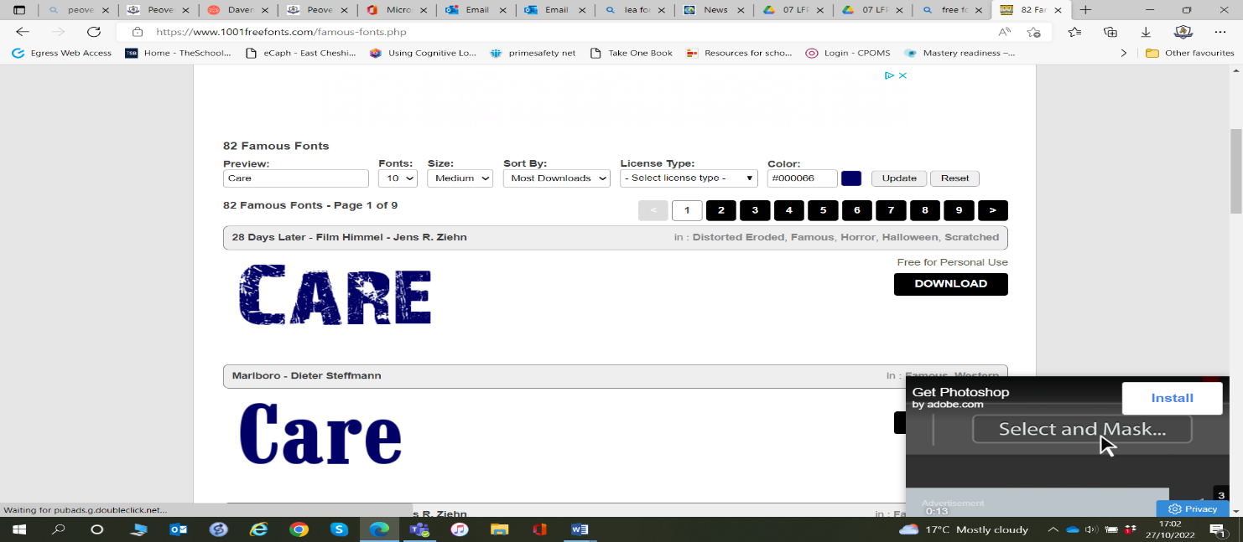
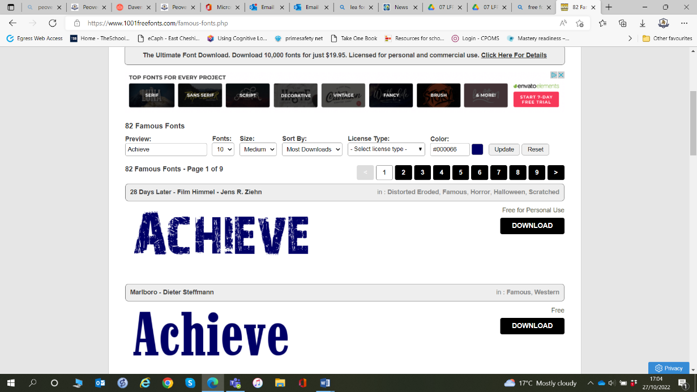
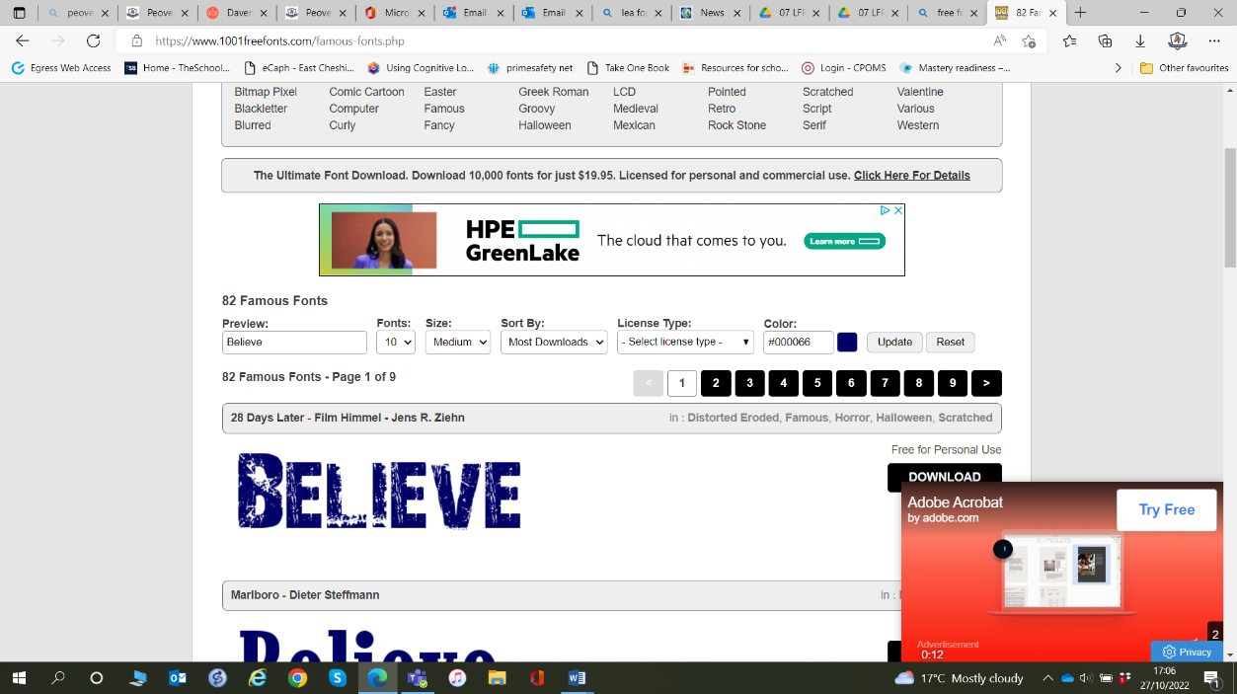

2026_2027

Autumn 1 – Belonging
Big Idea: We all belong and have a part to play.

School Value: Care
British Values: Everyone Is Welcome, Show Respect
Week 1 | Welcome to Our Peover Family  - Big Question: What does it mean to belong?
Week 2 | All Are Welcome  - Text: All Are Welcome  - Big Question: How can we make everyone feel welcome?
Week 3 | Celebrating Differences  - Text: All Are Welcome  - Big Question: Why are our differences important?
Week 4 | Friendship Matters  - Big Question: What makes a good friend?
Week 5 | Learning From Each Other  - Grandparents Afternoon Link - Enrichment  - Big Question: What can older generations teach us?
Week 6 | Our Peover Community  - Big Question: How do we help everyone belong?
Week 7 | Belonging Through Kindness  Big Question: How do small acts help people feel included?  Prepare for Kindness Challenge  Link to Mini Dukes  - Text Link: Have You Filled Your Bucket Today?  - Big Question: How do small acts help people feel included?
Week 8 | Our Peover Promise  - Big Question: What kind of community do we want to be?  Reflection on the half term  Children create a shared "Peover Promise"  Celebrate examples of belonging  Mini Dukes Challenge  "Help one person feel they belong this week."

