
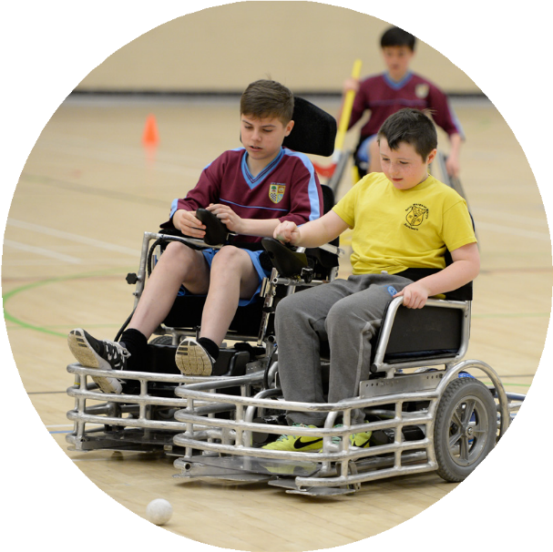
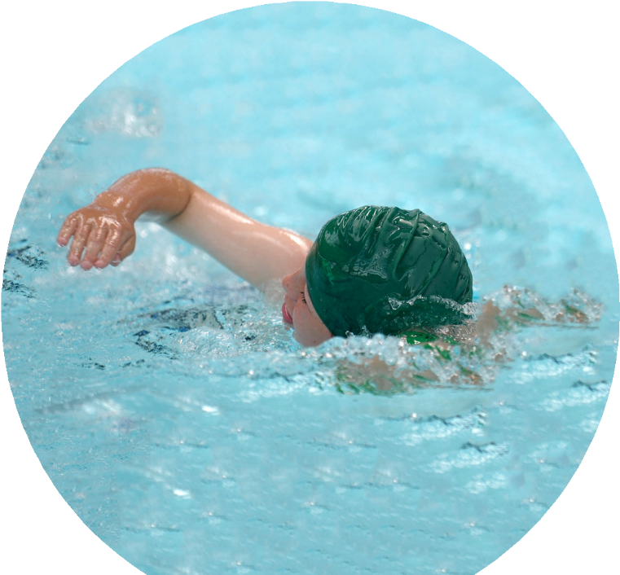
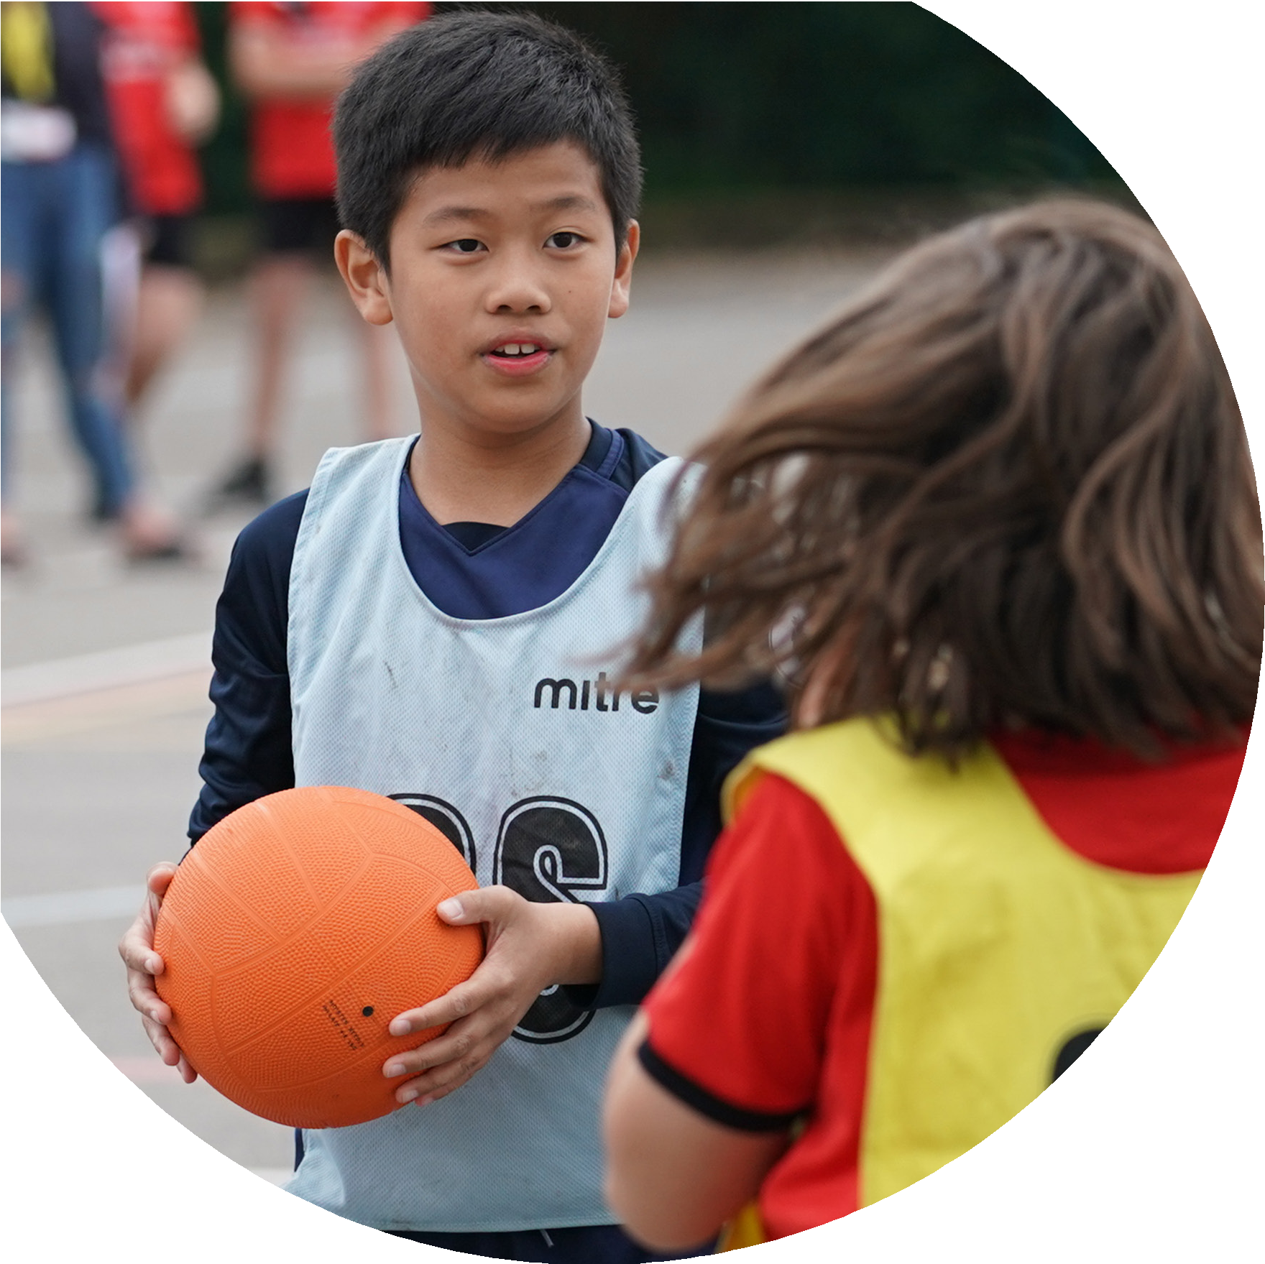



Evidencing the Impact of the Primary PE and Sport Premium
Website Reporting Tool Revised July 2024

Commissioned by

Created by


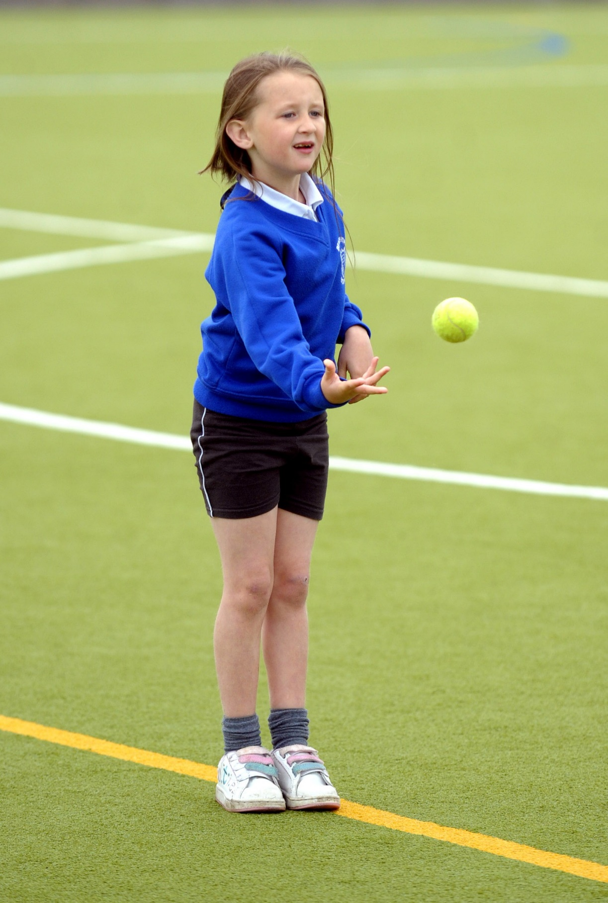
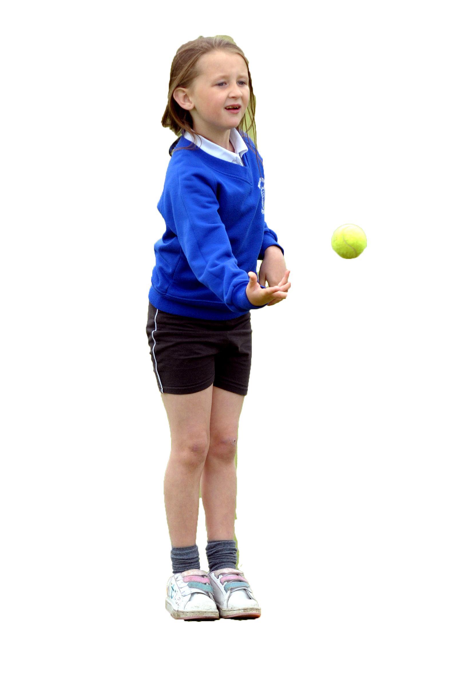

It is important that your grant is used effectively and based on school need. The Education Inspection Framework makes clear there will be a focus on ‘whether leaders and those responsible for governors all understand their respective roles and perform these in a way that enhances the effectiveness of the school’.

Under the Quality of Education Ofsted inspectors consider:
Intent - Curriculum design, coverage and appropriateness
Implementation - Curriculum delivery, Teaching (pedagogy) and Assessment
Impact - Attainment and progress

To assist schools with common transferable language this template has been developed to utilise the same three headings which should make your plans easily transferable between working documents.

Schools must use the funding to make additional and sustainable improvements to the quality of Physical Education, School Sport and Physical Activity (PESSPA) they offer. This means that you should use the Primary PE and sport premium to:

- Develop or add to the PESSPA activities that your school already offer
- Build capacity and capability within the school to ensure that improvements made now will benefit pupils joining the school in future years
- The Primary PE and sport premium should not be used to fund capital spend projects; the school’s budget should fund these.

Pleasevisitgov.ukfortherevisedDfEguidanceincludingthe5keyindicatorsacrosswhichschoolsshoulddemonstrate animprovement.Thisdocumentwillhelpyoutoreviewyourprovisionandtoreportyourspend.DfEencouragesschools to use this template as an effective way of meeting the reporting requirements of the Primary PE and Sport Premium.

We recommend you start by reflecting on the impact of current provision and reviewing the previous spend.

Schools are required to publish details of how they spend this funding, including any under-spend from 2023/2024, as well as on the impact it has on pupils’ PE and sport participation and attainment. All funding must be spent by 31st July 2024.

We recommend regularly updating the table and publishing it on your website throughout the year. This evidences your ongoing self-evaluation of how you are using the funding to secure maximum, sustainable impact. Final copy must be posted on your website by the end of the academic year and no later than the 31st July 2023. To see an example of how to complete the table please click HERE.


Created by: Supported by:

Details with regard to funding
Please complete the table below.

Total amount carried over from 2022/23 | £0
Total amount allocated for 2022/23 | £16800
How much (if any) do you intend to carry over from this total fund into 2023/24? | £1700
Total amount allocated for 2023/24 | £16800
Total amount of funding for 2023/24. To be spent and reported on by 31st July 2023. | £16800
Swimming Data
Please report on your Swimming Data below.

Meeting national curriculum requirements for swimming and water safety.

N.B. Complete this section to your best ability. For example, you might have practiced safe self-rescue techniques on dry land which you can then transfer to the pool when school swimming restarts.
Due to exceptional circumstances priority should be given to ensuring that pupils can perform safe self-rescue even if they do not fully meet the first two requirements of the NC programme of study
What percentage of your current Year 6 cohort swim competently, confidently and proficiently over a distance of at least 25 metres?  N.B. Even though your pupils may swim in another year please report on their attainment on leaving primary school at the end of the summer term 2023.  Please see note above | 100%
What percentage of your current Year 6 cohort use a range of strokes effectively [for example, front crawl, backstroke and breaststroke]?  Please see note above | 100%
What percentage of your current Year 6 cohort perform safe self-rescue in different water-based situations? | 100%
Schools can choose to use the Primary PE and sport premium to provide additional provision for swimming but this must be for activity over and above the national curriculum requirements. Have you used it in this way? | No

Action Plan and Budget Tracking
Capture your intended annual spend against the 5 key indicators. Clarify the success criteria and evidence of impact that you intend to measure to evaluate for pupils today and for the future.

Academic Year: 2023/24 | Total fund allocated: | Date Updated:
Key indicator 1: The engagement of all pupils in regular physical activity – Chief Medical Officers guidelines recommend that primary school pupils undertake at least 30 minutes of physical activity a day in school |  |  |  | Percentage of total allocation:
 |  |  |  | %
Intent | Implementation |  | Impact
Your school focus should be clear what you want the pupils to know and be able to do and about  what they need to learn and to  consolidate through practice: | Make sure your actions to achieve are linked to your intentions: | Funding allocated: | Evidence of impact: what do pupils now know and what can they now do? What has changed?: | Sustainability and suggested next steps:
All staff feel confident in delivering PE, especially in their weaker areas and for non-specialists so that they can work effectively together with coaches to ensure pupil engagement. | Arrange additional sessions with Sports Coaching Group to support additional coaching/teaching opportunities for all staff.  • Audit areas of need for staff – plan, monitor and evaluate sessions.  • TAs to observe professional sports coaching. Work alongside teachers to identify areas of need, plan and deliver specific PE sessions.  • Purchase new resources –  Footballs  Basketballs  Cricket balls  American Football  Dodgeballs  Golf Balls  Bean Bags  Space hoppers  As part of sports week –  Street Dancing -  Cricket  School to offer different lunchtime and after school sports clubs based on curriculum need and children’s own interests.  Playtime and lunchtime to take place on the school field to allow for greater freedom of play and a range of sports played | £13980 Sports Premium  £661.56  £41.90  £320  £80 | All pupils have had access to2 sessions a week with the Sports Coaching Group through weekly PE lessons. These lessons have involved a mixture of skills from ball skills, athletics, Tennis, Archery, Bochia, Cricket, Dance, Netball and football. Enabling our children to be confident in a full range of sporting activities and to take part in a variety of competitions outside of school.  Sports Coaching Group x 3 lunchtime sessions of sporting events  Outdoor shoes and wellies enabled children to have greater freedom of the school field at breaktimes and lunchtimes as well as for PE  Sports leaders have been appointed to organize and run activities during break and lunch times through PE lead.  A wider range of activities have been introduced such as which are encouraged to be played during break times;  Quidditch  Golf  Handball | Continue with this into the 2023/2024 academic year.  Provide questionnaire to staff, children and parents to ensure that PE is held with a high regard across school.
Key indicator 2: The profile of PESSPA being raised across the school as a tool for whole school improvement |  |  |  | Percentage of total allocation:
 |  |  |  | %
Intent | Implementation |  | Impact | 10%
Your school focus should be clear what you want the pupils to know and be able to do and about  what they need to learn and to  consolidate through practice: | Make sure your actions to achieve are linked to your intentions: | Funding allocated: | Evidence of impact: what do pupils now know and what can they now do? What has changed?: | Sustainability and suggested next steps:
All pupils have the opportunity to take part in a wide range of different sports across the year.  • All staff to have planned CPD in response to need | Continue to take part in National Schools Sports Week  • Plan CPD provision for all staff – teachers and TAs based on need  • TAs to lead specific additional inclusive PE sessions  • ‘Local Clubs’ and ‘P.E News’ boards to be maintained to promote clubs and celebrate our participation in competitions  Having a sports athlete in school and being part of a sporting sponsorship event. | Within £13980 Sports Coaching Group | Children have become more physically active and are using the school grounds to develop their skills and to ensure that they mental health and well-being is supported by being active outdoors. | Look to encourage all children to participate, ensuring involvement is monitored.  Arrange for more clubs and events to occur during school time.

Key indicator 3: Increased confidence, knowledge and skills of all staff in teaching PE and sport |  |  |  | Percentage of total allocation:
 |  |  |  | %
Intent | Implementation |  | Impact
Your school focus should be clear | Make sure your actions to | Funding | Evidence of impact: what do | Sustainability and suggested
what you want the pupils to know | achieve are linked to your | allocated: | pupils now know and what | next steps:
and be able to do and about | intentions: |  | can they now do? What has
what they need to learn and to |  |  | changed?:
consolidate through practice:
All staff feel confident in delivering PE, especially in their weaker areas and for non-specialist | Arrange additional sessions with Sports Coaching Group to support additional coaching/teaching opportunities for all staff.  • Audit areas of need for staff – plan, monitor and evaluate sessions.  • TAs to observe professional sports coaching. Work alongside teachers to identify areas of need, plan and deliver specific PE sessions. | Within £13980 Sports Coaching Group | Children now have a full range of PE skills which they have developed over the year. They have built up core knowledge in order to know more and remember more about different physical activities. | Encourage staff to actively observe and teach a string of lessons with the support of a sports coach and PE lead.
Key indicator 4: Broader experience of a range of sports and activities offered to all pupils |  |  |  | Percentage of total allocation:
Intent | Implementation |  | Impact
Your school focus should be clear | Make sure your actions to | Funding | Evidence of impact: what do | Sustainability and suggested
what you want the pupils to know | achieve are linked to your | allocated: | pupils now know and what | next steps:
and be able to do and about | intentions: |  | can they now do? What has
what they need to learn and to |  |  | changed?:
consolidate through practice:
All children to have access to a range of different sports  • Pupils to have some choice regarding the different sports they can experience for extracurricular clubs | • PE lead to work alongside external local sports clubs to provide alternative opportunities.  • Continue to provide free extra-curricular activities.  To offer residential experiences from year 2 upwards. | Within £13980 Sports Coaching Group | Children in all year groups have been able to access after school sports clubs and to take part in out of school tournaments and workshops – building team working and resilience. | To investigate residential opportunities for more classes.  To work with local sports clubs and try to involve as many of our children in clubs.

Key indicator 5: Increased participation in competitive sport |  |  |  | Percentage of total allocation:
 |  |  |  | %
Intent | Implementation |  | Impact
Your school focus should be clear | Make sure your actions to | Funding | Evidence of impact: what do | Sustainability and suggested
what you want the pupils to know | achieve are linked to your | allocated: | pupils now know and what | next steps:
and be able to do and about | intentions: |  | can they now do? What has
what they need to learn and to |  |  | changed?:
consolidate through practice:
All pupils have the opportunity to take part in competitive sport within their own class, with peers, at intra school events and inter school events. | Enter Holmes Chapel Comp Cluster events, including those aimed at children who do not currently participate in competitive sports beyond the school setting | £13980 Sports Coaching Group | Children across school have been involved with inter-sporting events held at HCC. They have developed confidence, resilience and team-working skills and have been proud to come back to school having won medals and representing our school community.  PE lead has arranged sporting events with local schools which have been held on our field. | To continue to work with the high school and local school to provide more events for children to participate in. Such as cross country, cricket, football, rugby etc.  To organise events for KS1 children.

Signed off by
Head Teacher: | Jo Munro
Date: | 6th July 2024
Subject Leader: | Mike Greatbanks
Date: | 2nd July 2024
Governor: | Liz Clover
Date: | 6nd July 2024

