Peover Superior Primary School

Child-friendly technology acceptable use agreement

At Peover Superior Primary School, we know that it can be fun to use technology as part of your learning experience. We want everyone to be able to use technology, like computers and tablets, but it is important that you are safe when you are using them.

We have created this agreement to help you understand how to be safe when you are using technology. Please read this carefully and sign your name to show that you understand your responsibilities when using technology. Ask your teacher if there is something that you do not understand.

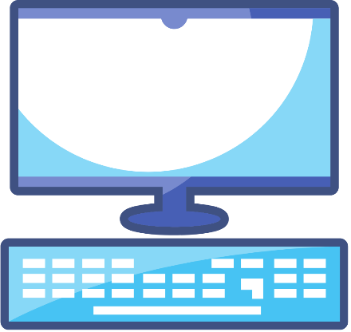
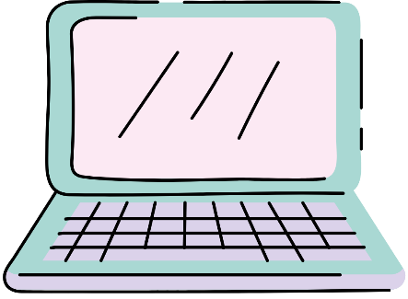

I will:


- Only use technology, such as a computer, when a teacher has given me permission.
- Only use technology for the reason I have been asked to use it.
- Only use the internet when a teacher has given me permission.
- Ask for help when I have a problem using the technology.
- Look after the device and try not to damage it.
- Tell the teacher if my device is not working or damaged.
- Tell the teacher if I think someone else is not using technology safely or correctly.
- Tell the teacher if I see something online that I think is inappropriate or that makes me upset.

I will not:

- Tell another pupil my username and password.
- Share personal information, such as my age and where I live, about myself or my friends online.
- Access social media, such as Facebook and WhatsApp.
- Speak to strangers on the internet.
- Take photos of myself or my friends using a school device.


Please read each statement and provide a tick to show that you agree, and then write your name below.

- I understand why it is important to use technology safely and correctly.
- I understand my responsibilities when using technology.
- I understand that I may not be allowed to use technology if I do not use it safely and correctly.
- I will follow these rules at all times.

Pupil name (please print): | ___________________________________
Date: | ___________________________________

Parent name (please print): | ___________________________________
Parent signature: | ___________________________________
Date: | ___________________________________

