Tapestry

Tuesday 16th June 2020

Dear Parents/Carers,

Over the last week I have set up both you and your child onto our online learning journey Tapestry. You should have received an activation email from Tapestry. If you click the link within the email it will take you directly to Tapestry where you will be able to activate your account.

Within this letter, I have set out a few simple step by step points on how to begin uploading observations onto Tapestry and to hopefully get you started on using the online learning journey over the Summer and this will then continue through to September.

I have attached this link: https://tapestry.info/support.html which will direct you Tapestry Online Forum and any frequently asked questions, which will hopefully answer any queries you may encounter. However, if there is anything at all that you need help with then please do not hesitate to ask and we will support you with this. I can also provide a small guide during home visits too.

I look forward to seeing your observations over the next few weeks, and what your children have been up to!

Yours sincerely

Miss Reeks
EYFS Lead

How to add an observation:

- Adding an observation
On your home page, you should see a button that says ‘Add Observation’ (see picture), firstly you need to click this and it will take you to the next step.
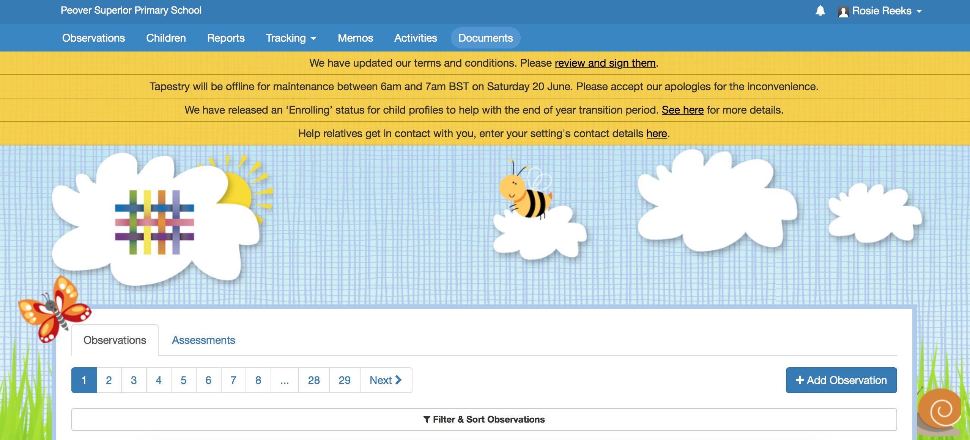

- Adding comments
You will then be taken to this page, this is where you can add a title for your observation (your child should automatically be added, mine just looks slightly different) and you can write any comments about the observation made. These can be things such as writing at home, numbers, playing, or anything that you would like to celebrate and share!

- Uploading Media
You can have the option to upload either a photo or a video to your observation. You can do this by clicking ‘add files’ and upload the files onto the observation.
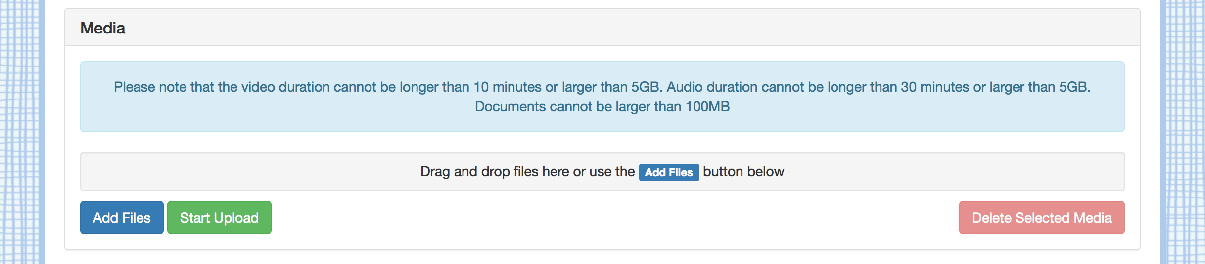

You will then press submit observation and I will be able to see it on my log in! I can then comment on each observation and you can comment back too.

